Project Report

# 

# BPSK Modulation and Demodulation

**Submitted By: Huzaifa Saleem Khan**

Table of Contents:

Contents

BPSK Modulation and Demodulation 1

Introduction 3

Literature Review 3

BPSK Modulation 3

BPSK Demodulation 4

BPSK Applications 4

Block Diagram 5

MATLAB Code 5

**BPSK Modulation and Demodulation**

# Introduction

The most straightforward type of PSK is called binary phase shift keying (BPSK), where “binary” refers to the use of two phase offsets (one for logic high, one for logic low). BPSK (Binary Phase Shift Keying) modulation technique, in which modulation types, are realized binary transfer. This modulation technique are very efficient for power consumption in their areas of application.

**S(t) = Acos(2πfct)**

## Literature Review

Binary Phase Shift Keying (BPSK) is a two phase modulation scheme, where the 0's and 1's in a binary message are represented by two different phase states in the carrier signal: for binary 1 and. for binary 0. In digital modulation techniques, a set of basic functions are chosen for a particular modulation scheme

This is also called as 2-phase PSK or Phase Reversal Keying. In this technique, the sine wave carrier takes two phase reversals such as 0° and 180°. BPSK is basically a Double Side Band Suppressed Carrier DSBSC modulation scheme, for message being the digital information .Its simplest technique.

# BPSK Modulation

The modulation of BPSK is done using a balance modulator, which multiplies the two signals applied at the input. For a zero binary input, the phase will be 0° and for a high input, the phase reversal is of 180°. Following is the diagrammatic representation of BPSK Modulated output wave along with its given input.

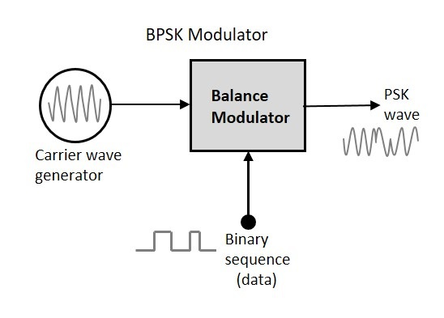

The following function (***bpsk_mod***) implements a baseband BPSK transmitter. The output of the function is in baseband and it can optionally be multiplied with the carrier frequency outside the function. In order to get nice continuous curves, the oversampling factor (L) in the simulation should be appropriately chosen.

# BPSK Demodulation

The block diagram of BPSK demodulator consists of a mixer with local oscillator circuit, a band pass filter, a two-input detector circuit. The diagram is as follows

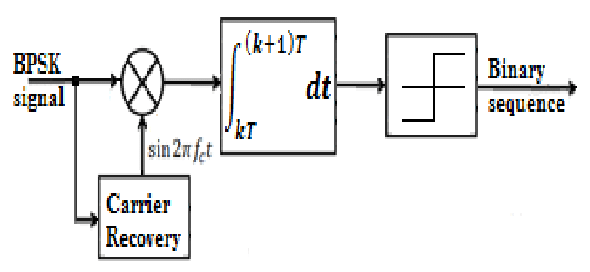

The function **bpsk_demod**, implements a ***baseband*** BPSK receiver. To use this function in waveform simulation, first, the received waveform has to be down converted to baseband, and then the function may be called.

# BPSK Applications

BPSK offer several distinct properties different from other modulation techniques due to which it can be used in data transmission with lower data rates that is BPSK found its most implies applications in low speed communication systems.

The BPSK modulation is a very basic technique used in various wireless standards such as Satellite, DVB, and Cable modem.

# Block Diagram

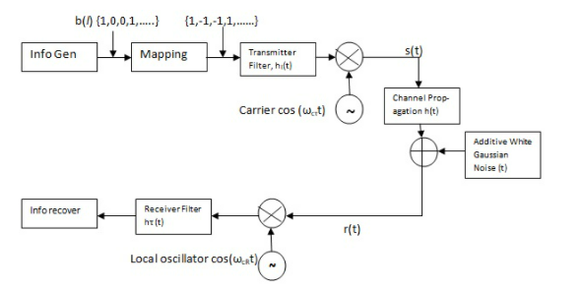

# MATLAB Code

clc;

clear all;

close all;

% Digital Binary input information

x = input('Enter Digital Input Information in Binary = ');

N = length(x);

Tb = 0.0001; %Data rate = 1MHz i.e., bit period (second)

disp('Binary Input Information at Transmitter end: ');

disp(x);

% Represent input information as digital signal

nb = 100; % Digital signal per bit

digit = [];

for n = 1:1:N

if x(n) == 1;

sig = ones(1,nb);

else x(n) == 0;

sig = zeros(1,nb);

end

digit = [digit sig];

end

t1=Tb/nb:Tb/nb:N*Tb; % Time period

figure('Name','BPSK Modulation and Demodulation for Final Lab'); %Title for figure

subplot(3,1,1);

plot(t1,digit,'lineWidth',2.5);

grid on;

xlabel('Time)');

ylabel('Amplitude');

title ('Digital Input Signal');

% BPSK Modulation

Ac = 10; % Carrier Amplitude

br = 1/Tb; % Bit Rate

Fc = br*16; % Carrier Frequency

Pc1 = 0; % Carrier Phase for binary input '1'

Pc2 = pi; % Carrier Phase for binary input '0'

t2 = Tb/nb:Tb/nb:Tb; % Signal time

mod = [];

for (i = 1:1:N)

if (x(i)==1)

y = Ac*cos(2*pi*Fc*t2+Pc1); % Modulation signal with carrier signal 1

else

y = Ac*cos(2*pi*Fc*t2+Pc2); % Modulation signal with carrier signal 2

end

mod=[mod y];

end

t3=Tb/nb:Tb/nb:Tb*N; % Time period

subplot(3,1,2);

plot(t3,mod);

xlabel('Time(Sec)');

ylabel('Amplitude(Volts)');

title('BPSK Modulated Signal');

% Transmitted signal x

x = mod;

% Channel model h and w

h = 1; % Signal fading

w = 0; % Noise

% Received signal y

y = h.*x + w; % Convolution

% BPSK Demodulation

s = length(t2);

demod = [];

for n = s:s:length(y)

t4 = Tb/nb:Tb/nb:Tb;

c = cos(2*pi*Fc*t4); % carrier siignal

mm = c.*y((n-(s-1)):n); % Convolution

t5 = Tb/nb:Tb/nb:Tb;

z = trapz(t5,mm); % intregation

rz = round((2*z/Tb));

if(rz > Ac/2) % Logical condition

a = 1;

else

a = 0;

end

demod = [demod a];

end

disp('Demodulated Binary Information at Receiver end: ');

disp(demod);

% Represent demodulated information as digital signal

digit = [];

for n = 1:length(demod);

if demod(n) == 1;

sig = ones(1,nb);

else demod(n) == 0;

sig = zeros(1,nb);

end

digit = [digit sig];

end

t5=Tb/nb:Tb/nb:nb*length(demod)*(Tb/nb); % Time period

subplot(3,1,3)

plot(t5,digit,'LineWidth',2.5);

grid on;

xlabel('Time(Sec)');

ylabel('Amplitude(Volts)');

title('BPSK Demodulated Signal');